Apache快速设置虚拟主机脚本

目录

Apache快速设置虚拟主机脚本 1

一、 项目背景意义和需求分析 1

1. 背景意义： 1

2. 需求分析： 2

二、 术语解释 2

1. 虚拟主机： 2

2. Lamp环境： 2

三、 系统搭建 2

1. DHCP服务器搭建 3

2. DNS服务器搭建 3

3. APACHE MYSQL服务器搭建 5

4. 控制APACHE服务器虚拟主机脚本 7

四、 功能说明 14

1. 显示apache网页服务器状态、虚拟主机配置和firewall防火墙状态 15

2. 添加虚拟主机 15

3. 移除虚拟主机 16

4. 修改虚拟主机 18

5. 打开防火墙并且添加http服务永久生效 21

6. 打开防火墙并且移除http服务永久生效 23

7. 退出脚本 23

五、 总结与展望 24

总结： 24

展望： 24

六、 参考文献 24

## 项目背景意义和需求分析

### 背景意义：

Apache虚拟主机就是在一个Apache服务器上配置多个虚拟主机，实现一个服务器提供多站点服务，其实就是访问同一个服务器上的不同目录。本项目搭建了dhcp服务器，分配固定ip：192.168.170.101给apache服务器，分配固定ip：192.168.170.102给dns服务器。dns服务器提供域名解析。

### 需求分析：

当修改添加一台虚拟主机到Apache服务器时，常用的方式为修改配置文件，而修改配置文件容易出错，导致整个服务器启动不了。而使用shell提前编写规则，修改配置文件，等待用户输入参数后，大大减小手动输入出错的概率。为了便于使用，脚本还提供apache服务器状态查看，防火墙配置功能。

## 术语解释

### 虚拟主机：

Apache虚拟主机就是在一个Apache服务器上配置多个虚拟主机，实现一个服务器提供多站点服务，访问同一个服务器上的不同目录。

### Lamp环境：

本项目使用的是centos7+Apache+ mariadb+php

## 系统搭建

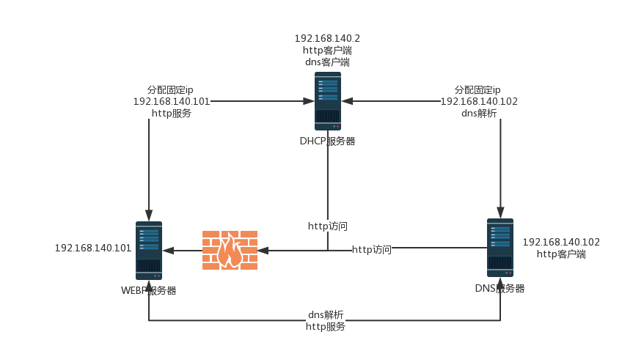

网络系统拓补图

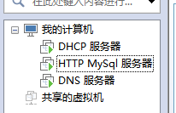

VM虚拟机

### DHCP服务器搭建

安装

yum -y install dhcp

配置文件

vim /etc/dhcp/dhcpd.conf

ault-lease-time 600;

max-lease-time 7200;

subnet 192.168.140.0 netmask 255.255.255.0 {

range 192.168.140.10 192.168.140.20;

option routers 192.168.140.1;

option broadcast-address 192.168.255.255;

host httpserve {

hardware ethernet 00:0c:29:80:25:bf;

fixed-address 192.168.140.101;

}

host dnsserve {

hardware ethernet 00:0c:29:53:c0:1a;

fixed-address 192.168.140.102;

}

}

### DNS服务器搭建

安装

yum -y install bind

配置文件

vim /etc/named.conf

options {

directory "/var/named";

dump-file "/var/named/data/cache_dump.db";

statistics-file "/var/named/data/named_stats.txt";

};

zone "jzg.com" IN {

type master;

file "jzg.com";

};

zone "140.168.192.in-addr.arpa" {

type master;

file "140.168.192";

};

zone "niuini.com" IN {

type master;

file "niuini.com";

};

正向解析文件

vim /var/named/jzg.com

86400

jzg.com. IN SOA dns.jzg.com. adminemail.jzg.com (

20180511; serial

1H ; refresh

15M ; retry

1W ; expire

1D ) ; minimum

jzg.com. IN NS dns.jzg.com.

www IN A 192.168.140.101

dns IN A 192.168.140.102

bbs IN A 192.168.140.101

niuini IN A 192.168.140.101

jzg.com. IN A 192.168.140.101

ftp IN CNAME www

other IN A 192.168.140.103

正向解析文件

vim /var/named/niuini.com

$TTL 86400

niuini.com. IN SOA dns.niuini.com. adminemail.jzg.com (

20180511; serial

1H ; refresh

15M ; retry

1W ; expire

1D ) ; minimum

niuini.com. IN NS dns.niuini.com.

www IN A 192.168.140.101

dns IN A 192.168.140.102

niuini.com. IN A 192.168.140.101

ftp IN CNAME www

other IN A 192.168.140.103

反向解析文件

$TTL 86400

@ IN SOA 140.168.192.in-addr.arpa. root.fqnu.org (

20180511 ; serial

1H ; refresh

15M ; retry

1W ; expire

1D ) ; minimum

@ IN NS dns.jzg.com.

101 IN PTR www.jzg.com.

101 IN PTR jzg.com.

101 IN PTR www.niuini.com.

101 IN PTR niuini.com.

102 IN PTR dns.jzg.com.

103 IN PTR other.jzg.com.

### APACHE MYSQL服务器搭建

安装

yum -y install httpd mariadb mariadb-server php php-mysql php-gd php-xml

配置文件

# 根目录

ServerRoot "/etc/httpd"

Listen 80

# 超时时间（秒）

Timeout 400

Include conf.modules.d/*.conf

User apache

Group apache

ServerAdmin admin@niuini.com

# 主机地址

ServerName 192.168.140.101:80

<Directory />

AllowOverride none

Require all denied

</Directory>

# Apache 文档根目录

DocumentRoot "/var/www/html"

<Directory "/var/www">

AllowOverride None

# Allow open access:

Require all granted

</Directory>

<Directory "/var/www/html">

# Indexes 允许目录浏览

# Options Indexes FollowSymLinks

Options Indexes FollowSymLinks

AllowOverride None

Require all granted

</Directory>

<IfModule dir_module>

DirectoryIndex index.html index.php

</IfModule>

<Files ".ht*">

Require all denied

</Files>

ErrorLog "logs/error_log"

LogLevel warn

<IfModule log_config_module>

LogFormat "%h %l %u %t \"%r\" %>s %b \"%{Referer}i\" \"%{User-Agent}i\"" combined

LogFormat "%h %l %u %t \"%r\" %>s %b" common

<IfModule logio_module>

# You need to enable mod_logio.c to use %I and %O

LogFormat "%h %l %u %t \"%r\" %>s %b \"%{Referer}i\" \"%{User-Agent}i\" %I %O" combinedio

</IfModule>

CustomLog "logs/access_log" combined

</IfModule>

<IfModule alias_module>

ScriptAlias /cgi-bin/ "/var/www/cgi-bin/"

</IfModule>

<Directory "/var/www/cgi-bin">

AllowOverride None

Options None

Require all granted

</Directory>

<IfModule mime_module>

AddType text/html .shtml

AddOutputFilter INCLUDES .shtml

</IfModule>

AddDefaultCharset UTF-8

<IfModule mime_magic_module>

MIMEMagicFile conf/magic

</IfModule>

IncludeOptional conf.d/*.conf

NameVirtualHost *:80

<VirtualHost *:80>

DocumentRoot /var/www/html/

ServerName jzg.com

</VirtualHost>

<VirtualHost *:80>

DocumentRoot /var/www/html2/

ServerName niuini.com

</VirtualHost>

<VirtualHost *:80>

DocumentRoot /var/www/html2/

ServerName www.niuini.com

</VirtualHost>

### 控制APACHE服务器虚拟主机脚本

#!/bin/bash

# this program is control Apache virtual host server

# Date:2018-06-23

# Version:1.0

# Author: jiang zhi gang

# 全局变量

ConfRootDir=""

AddVirtalConfFile(){

# 匹配行 取第二个 删除引号

ConfRoot=`awk '/^ServerRoot/' /etc/httpd/conf/httpd.conf| awk '{print $2}'| sed 's/"//g'`

ConfDir=`awk '/^IncludeOptional/' /etc/httpd/conf/httpd.conf | awk '{print $2}'| awk -F"/" '{print $1}'`

Virtual="virtual.conf"

VirtalConfFile="$ConfRoot/$ConfDir/$Virtual"

echo "Virtal Host Conf File is virtual.conf Located In $ConfRoot/$ConfDir"

PrintLine

# 查询是否存在虚拟机配置文件

if [ ! -f "$VirtalConfFile" ]

then

echo "No $Virtual File, Will Creat It!"

touch "$VirtalConfFile"

fi

}

PrintLine(){

echo "--------------------------------------------------------------------"

}

# 显示配置文件中的虚拟主机

ExistingVirtualHost(){

printf "The virtual Host That Exists In The Conf file: \n\n"

# \s空格 任意空格开头+ServerName 的行 ServerName结果集

Existing=`awk '/^\s*ServerName/' $VirtalConfFile `

if [ -z "$Existing" ]

then

echo "Conf File Is Empty!"

PrintLine

return 0

else

# 输出匹配的当前行和下一行

awk '/^\s*ServerName/{printf ""$0"\n";getline;printf ""$0"\n\n";}' $VirtalConfFile

PrintLine

return 1

fi

}

ApacheStatus(){

PrintLine

echo "Show Virtual Host And Apache Status , Firewall Status:"

AddVirtalConfFile

ExistingVirtualHost

#显示apache相关配置信息

echo "Apache Status:"

systemctl status httpd |grep Active

# Net Stat

REQUEST_NUM=`systemctl status httpd | grep Status | awk '{print $4}'| sed 's/;//'`

echo "Request Number: $REQUEST_NUM"

NETSTAT=`netstat -tunpl | grep httpd`

printf "Net Stat: \n $NETSTAT\n"

PrintLine

# 显示Firewall相关配置信息

echo "Firewall Status:"

systemctl status firewalld |grep Active

DefaultZone=`firewall-cmd --get-default-zone`

FirewallServices=`firewall-cmd --zone=$ActiveZones --list-all | grep services |awk -F":" '{print $2}'`

echo "Default Zone:$DefaultZone"

echo "Services:$FirewallServices"

}

AddVirtual(){

PrintLine

echo "Add Virtual Host:"

AddVirtalConfFile

NameVirtualHost=`awk '/^NameVirtualHost/' /etc/httpd/conf/httpd.conf| awk '{print $2}'`

# 允许本机所有80端口网络通过 基于域名的虚拟主机

if [ "$NameVirtualHost" != "*:80" ]

then

echo "Add NameVirtualHost *:80 >> /etc/httpd/conf/httpd.conf"

echo "NameVirtualHost *:80" >> /etc/httpd/conf/httpd.conf

fi

ExistingVirtualHost $VirtalConfFile

read -p "Please input ServerName( www.example.com ):" ServerName

# 输入ServerName是否为空

if [ -z $ServerName ]

then

echo "Please Input ServerName"

else

read -p "Please input DocumentRoot( /var/www/html/ ):" DocumentRoot

# 输入DocumentRoot是否为空

if [ -z $DocumentRoot ]

then

echo "Please Input DocumentRoot"

else

# 写配置文件

(

cat <<EOF

# ShellCript Creat ServerName $ServerName Begin

<VirtualHost *:80>

ServerName $ServerName

DocumentRoot $DocumentRoot

</VirtualHost>

# ShellCript Creat ServerName $ServerName End

EOF

) >> $VirtalConfFile

# 写配置文件

PrintLine

echo "Add Succeed!"

cat $VirtalConfFile

systemctl restart httpd

fi

fi

}

RemoveVirtual(){

PrintLine

echo "Remove Virtual Host:"

AddVirtalConfFile

ExistingVirtualHost $VirtalConfFile

# 配置文件是否为空

if [ $? == "0" ]

then

echo "No Virtual Host Can Be Removed!"

else

read -p "Please Select ServerName Remove It:" ServerName

result=`cat $VirtalConfFile | grep "# ShellCript Creat ServerName $ServerName Begin"`

# 输入是否为空

if [ -z $ServerName ]

then

echo "Please Input ServerName"

# 输入查询结果是否为空

elif [ -z "$result" ]

then

echo "Please Input Existing ServerName"

# 输入正确

else

sed -i "/# ShellCript Creat ServerName $ServerName Begin/,/# ShellCript Creat ServerName $ServerName End/d" $VirtalConfFile

PrintLine

echo "Remove Succeed!"

cat $VirtalConfFile

systemctl restart httpd

fi

fi

}

ModifyVirtual(){

PrintLine

echo "Modify Virtual Host:"

AddVirtalConfFile

ExistingVirtualHost $VirtalConfFile

# 配置文件是否为空

if [ $? == "0" ]

then

echo "No Virtual Host Can Be Modify !"

else

read -p "Please Select ServerName Modify It:" ServerName

result=`cat $VirtalConfFile | grep "# ShellCript Creat ServerName $ServerName Begin"`

# 输入是否为空

if [ -z "$ServerName" ]

then

echo "Please Input ServerName"

# 输入查询结果是否为空

elif [ -z "$result" ]

then

echo "Please Input Existing ServerName"

# 输入正确

else

# 显示要修改的内容

sed -n "/# ShellCript Creat ServerName $ServerName Begin/,/# ShellCript Creat ServerName $ServerName End/p" $VirtalConfFile

PrintLine

printf "What to Modify ? \n"

MENU "1" "ServerName:"

MENU "2" "DocumentRoot:"

MENU "3" "Back:"

read -p "please select a function(1-3):" U_SELECT

case $U_SELECT in

1)

read -p "Please Input New ServerName:" NewServerName

if [ -z "$NewServerName" ]

then

echo "Please Input NewServerName!"

else

sed -i "s/ServerName $ServerName/ServerName $NewServerName/g" $VirtalConfFile

PrintLine

echo "Modify ServerName Succeed!"

cat $VirtalConfFile

systemctl restart httpd

fi

;;

2)

read -p "Please Input New DocumentRoot:" NewDocumentRoot

if [ -z "$NewDocumentRoot" ]

then

echo "Please Input NewDocumentRoot!"

else

# sed 中有/ 需要添加转义字符\

NewDocumentRoot=$(echo $NewDocumentRoot | sed 's/\//\\\//g')

# echo $NewDocumentRoot

sed -i "/^\s*ServerName $ServerName/{n;s/DocumentRoot.*/DocumentRoot $NewDocumentRoot/;}" $VirtalConfFile

PrintLine

echo "Modify DocumentRoot Succeed!"

cat $VirtalConfFile

systemctl restart httpd

fi

;;

3)

echo "Back..."

;;

*)

echo "Please Select 1-3"

;;

esac

fi

fi

}

# 关闭Selinux 打开Firewalld

CloseSeOpenFw(){

SeStatus=`getenforce`

echo "Selinux Status:$SeStatus"

if [ $SeStatus != "Disabled" ]

then

read -p "Do You Want To Close Selinux? Y/N(suggest closing it): " Close

if [ $Close == "y" && $Close == "Y"]

then

sed -i 's/SELINUX=enforcing/SELINUX=disabled/' /etc/selinux/config

sed -i 's/SELINUX=permissive/SELINUX=disabled/' /etc/selinux/config

# 临时关闭SELinux

setenforce 0

echo "Close Selinux Succeed!"

else

echo "Selinux is $SeStatus Do't Close It!"

fi

fi

FWStatus=`firewall-cmd --stat`

echo "Firewalld Status:$FWStatus"

if [ $FWStatus != "running" ]

then

read -p "Do You Want To Open Firewalld? Y/N(suggest open it): " Close

if [ $Close == "y" && $Close == "Y"]

then

systemctl restart firewalld

echo "Open Firewalld Succeed!"

return 1

else

echo "Selinux is $FWStatus Do't Open It!"

return 0

fi

fi

return 1

}

Addhttp(){

CloseSeOpenFw

if [ $? == "0" ]

then

echo "Please Open Firewalld !"

else

DefaultZone=`firewall-cmd --get-default-zone`

FirewallServices=`firewall-cmd --zone=$ActiveZones --list-all | grep services |awk -F":" '{print $2}'`

echo "Default Zone:$DefaultZone"

echo "Services:$FirewallServices"

Result=`echo $FirewallServices | awk /http/ `

if [ -z "$Result" ]

then

echo "Add Http Service:"

firewall-cmd --zone="$DefaultZone" --add-service=http --permanent

firewall-cmd --zone="$DefaultZone" --add-service=http

else

echo "Http Services Already Exist In $DefaultZone Zone"

fi

fi

}

Removehttp(){

CloseSeOpenFw

if [ $? == "0" ]

then

echo "Please Open Firewalld !"

else

DefaultZone=`firewall-cmd --get-default-zone`

FirewallServices=`firewall-cmd --zone=$ActiveZones --list-all | grep services |awk -F":" '{print $2}'`

echo "DefaultZone:$DefaultZone"

echo "Services:$FirewallServices"

Result=`echo $FirewallServices | awk /http/ `

if [ -z "$Result" ]

then

echo "Http Services NO Already Exist In $DefaultZone Zone"

else

echo "Remove Http Service:"

firewall-cmd --zone="$DefaultZone" --remove-service=http --permanent

firewall-cmd --zone="$DefaultZone" --remove-service=http

fi

fi

}

HINT(){

read -p "Press Enter to continue:"

}

MENU(){

if [ $1 == "1" ]

then

printf "+----------------------------------------+\n"

fi

printf "|%2s. %-35s |\n" "$1" "$2"

printf "+----------------------------------------+\n"

}

while true

do

clear

printf " Control Apache virtual Host Server\n"

MENU "1" "Apache And Firewalld Status:"

MENU "2" "Add Virtual Host:"

MENU "3" "Remove Virtual Host:"

MENU "4" "Modify Virtual Host:"

MENU "5" "Open Firewalld --> Add http:"

MENU "6" "Open Firewalld --> Remove http:"

MENU "7" "Exit Script:"

read -p "please select a function(1-7):" U_SELECT

case $U_SELECT in

1)

ApacheStatus

HINT

;;

2)

AddVirtual

HINT

;;

3)

RemoveVirtual

HINT

;;

4)

ModifyVirtual

HINT

;;

5)

Addhttp

HINT

;;

6)

Removehttp

HINT

;;

7)

exit

;;

*)

read -p "Please Select 1-7,Press Enter to continue:"

esac

done

## 功能说明

**主菜单**

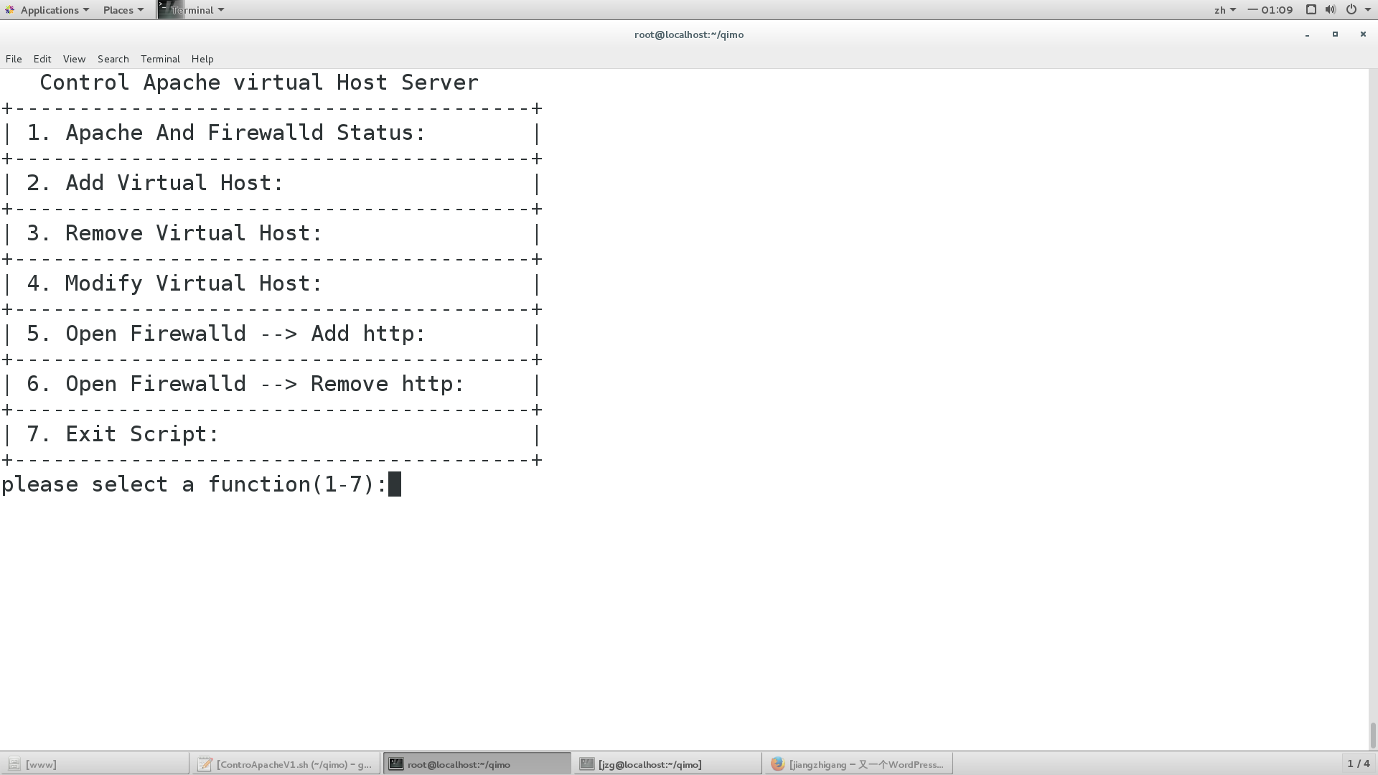

### 显示apache网页服务器状态、虚拟主机配置和firewall防火墙状态

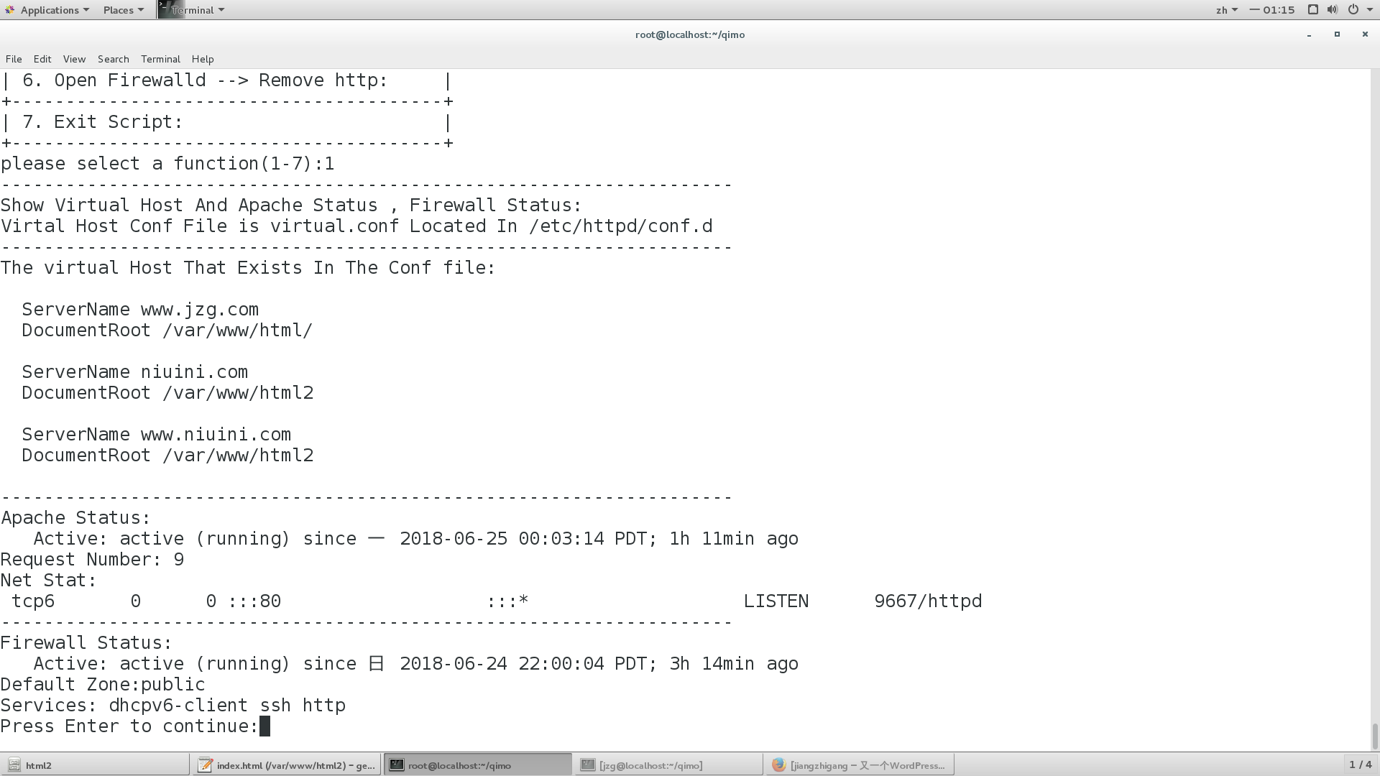

### 添加虚拟主机

输入添加的主机域名和目录 输入jzg.com 目录 /var/www/html3/

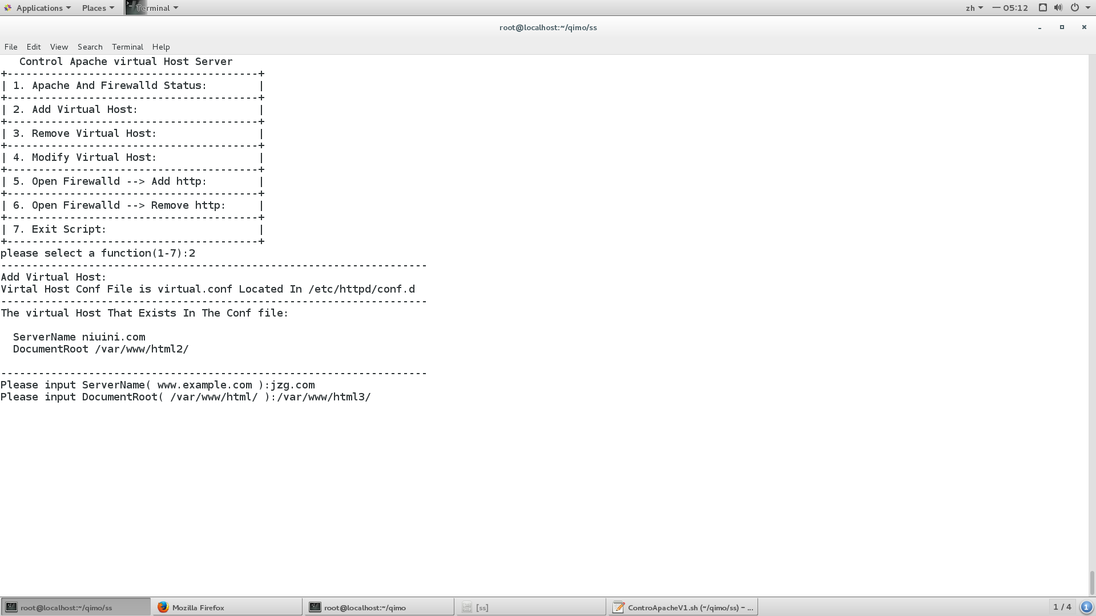

添加成功 重启服务器

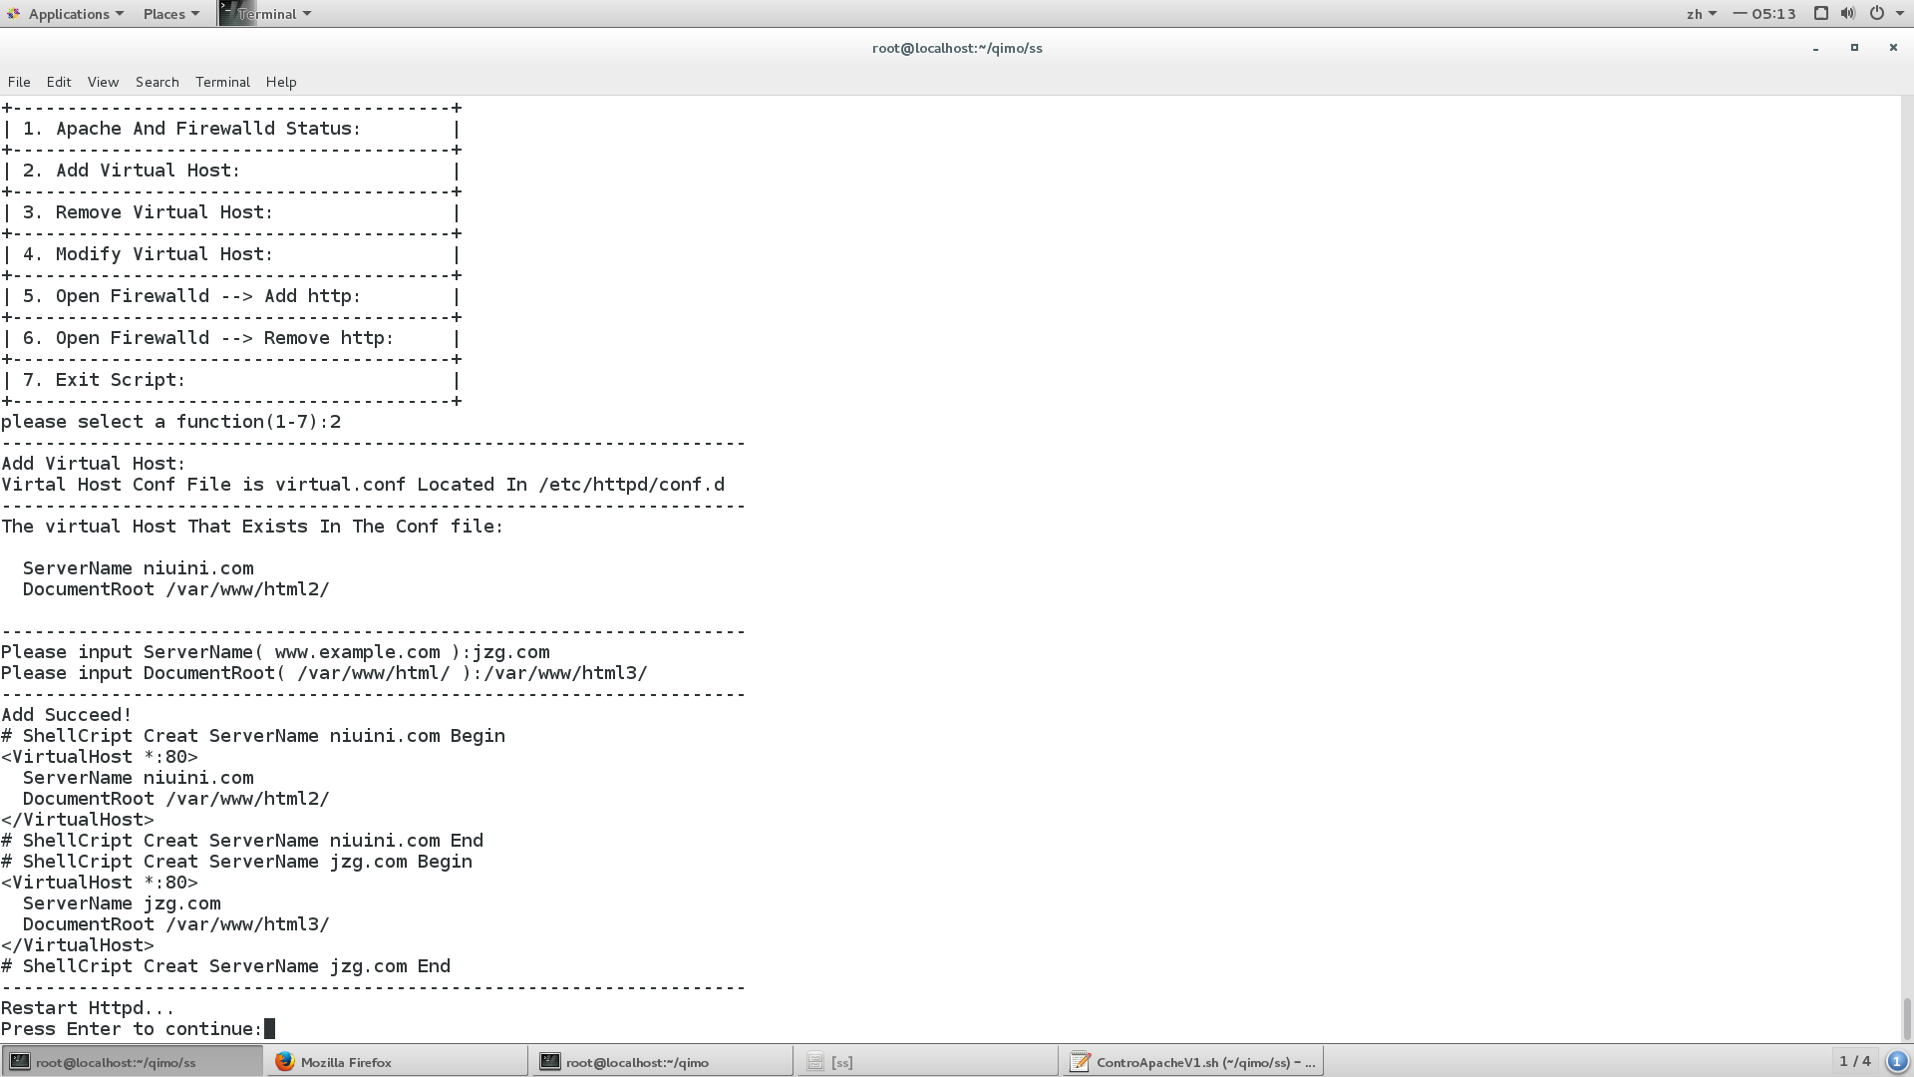

访问成功 /var/www/html3/index.html

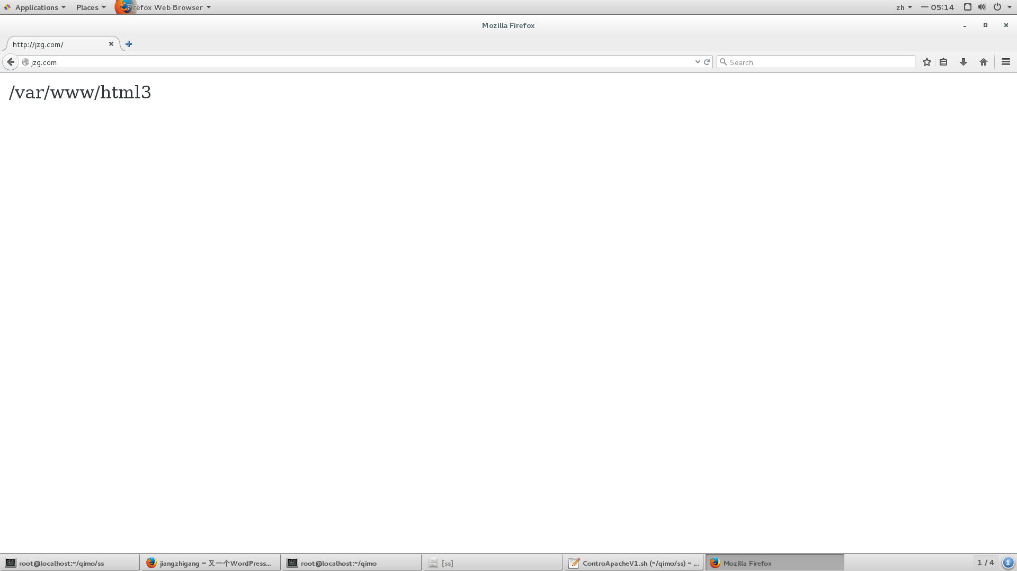

### 移除虚拟主机

输入需要移除的主机域名

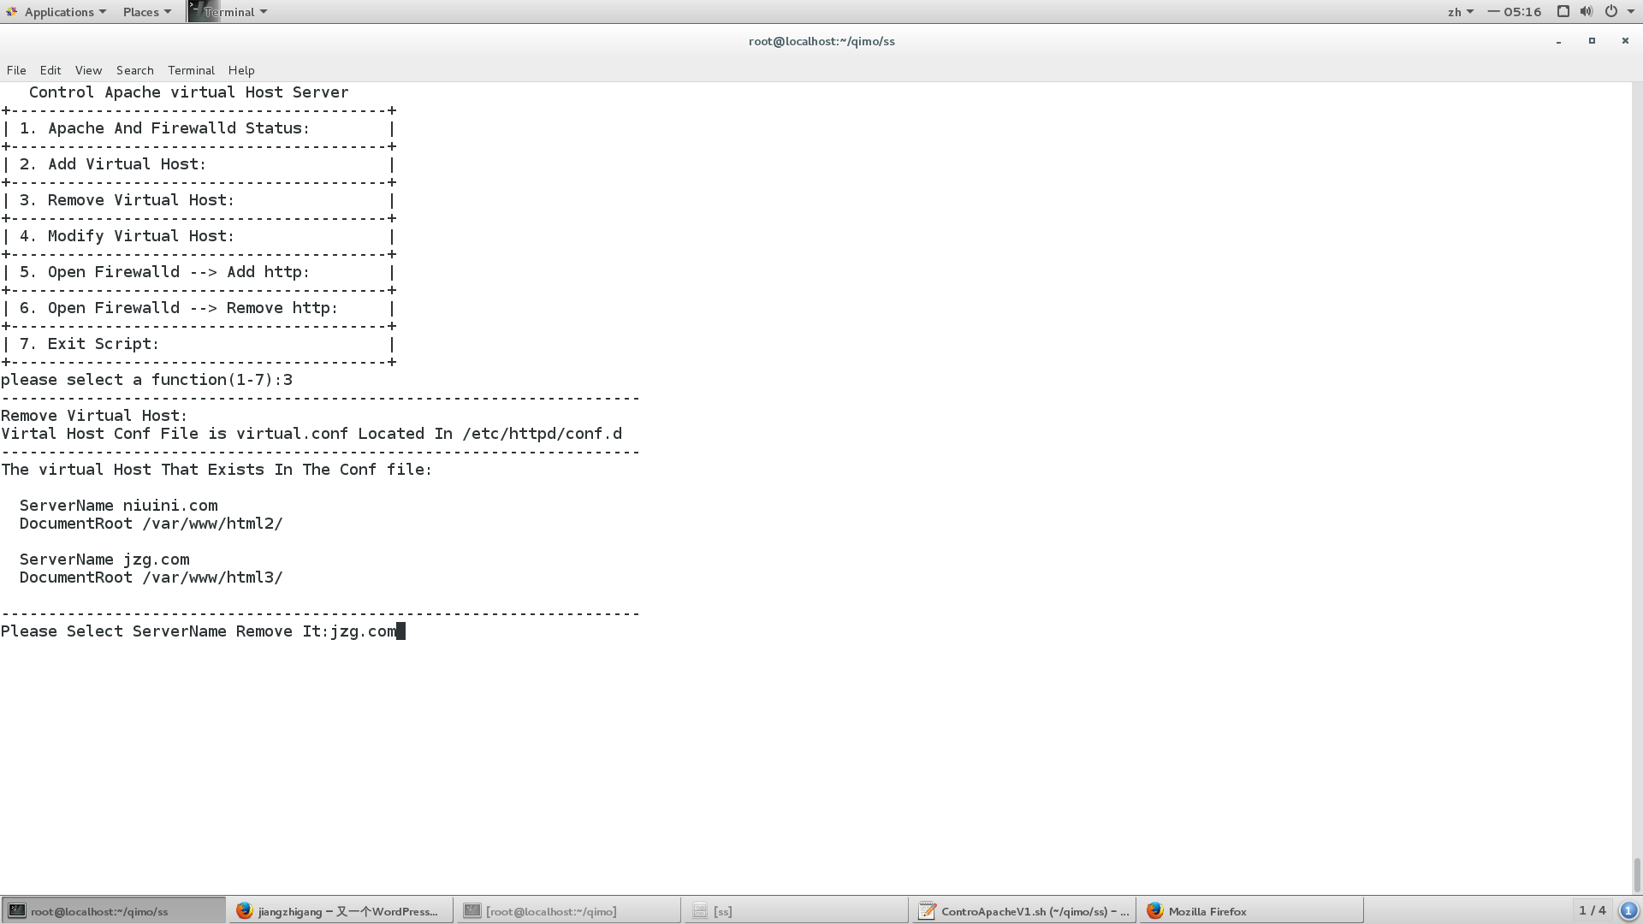

输入不存在配置文件中的域名会提示重新输入

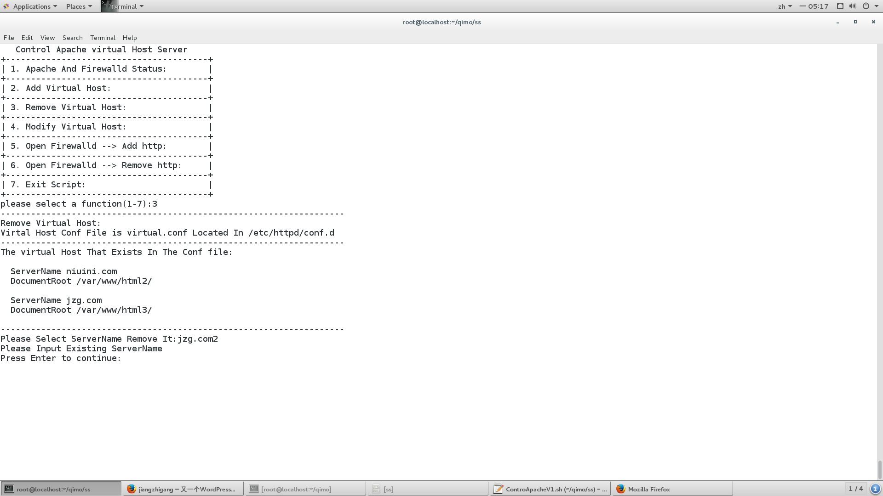

输入正确，移除成功 重启服务器

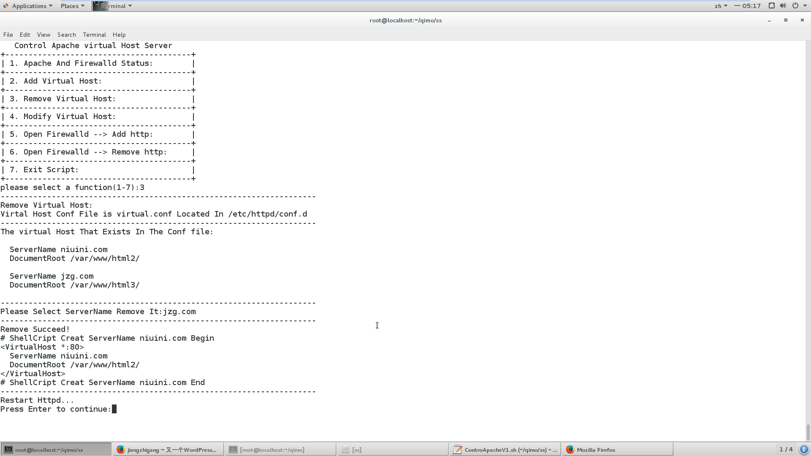

移除后 以第一个虚拟主机的目录为默认根目录

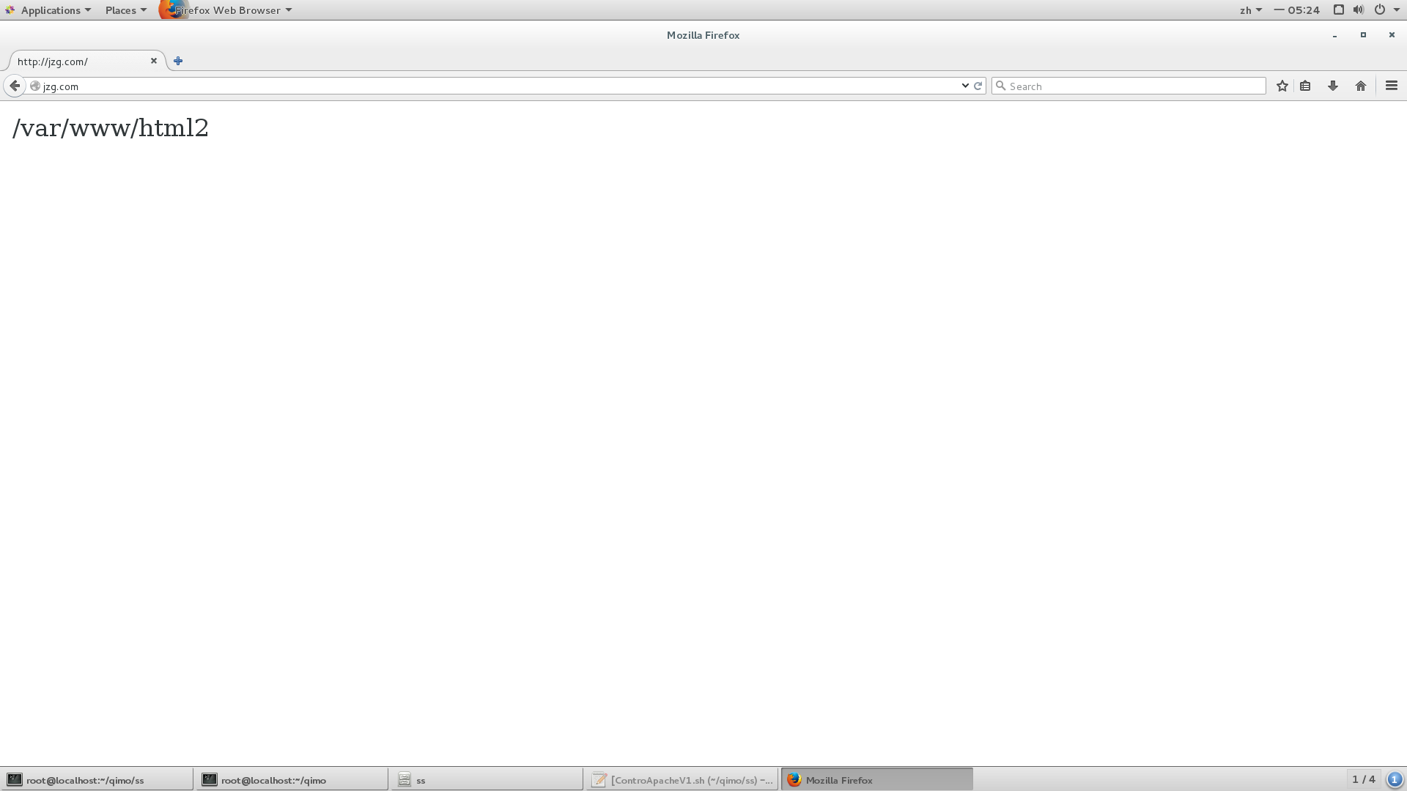

### 修改虚拟主机

输入需要修改的主机域名

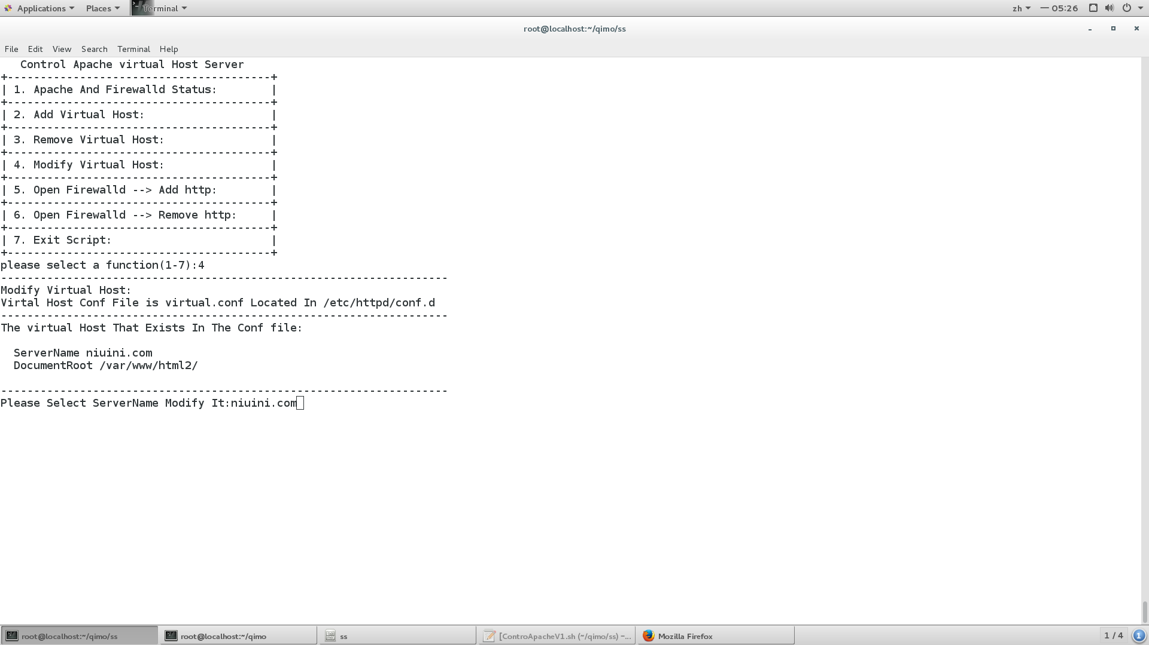选择修改域名还是文档目录

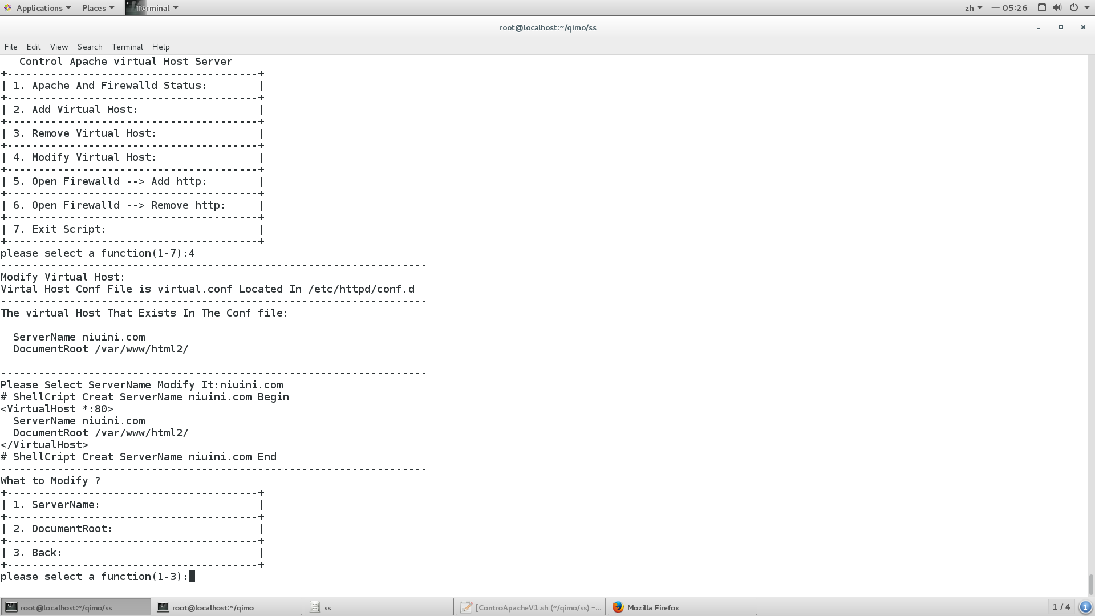

修改域名成功修改为[www.niuini.com](http://www.niuini.com)

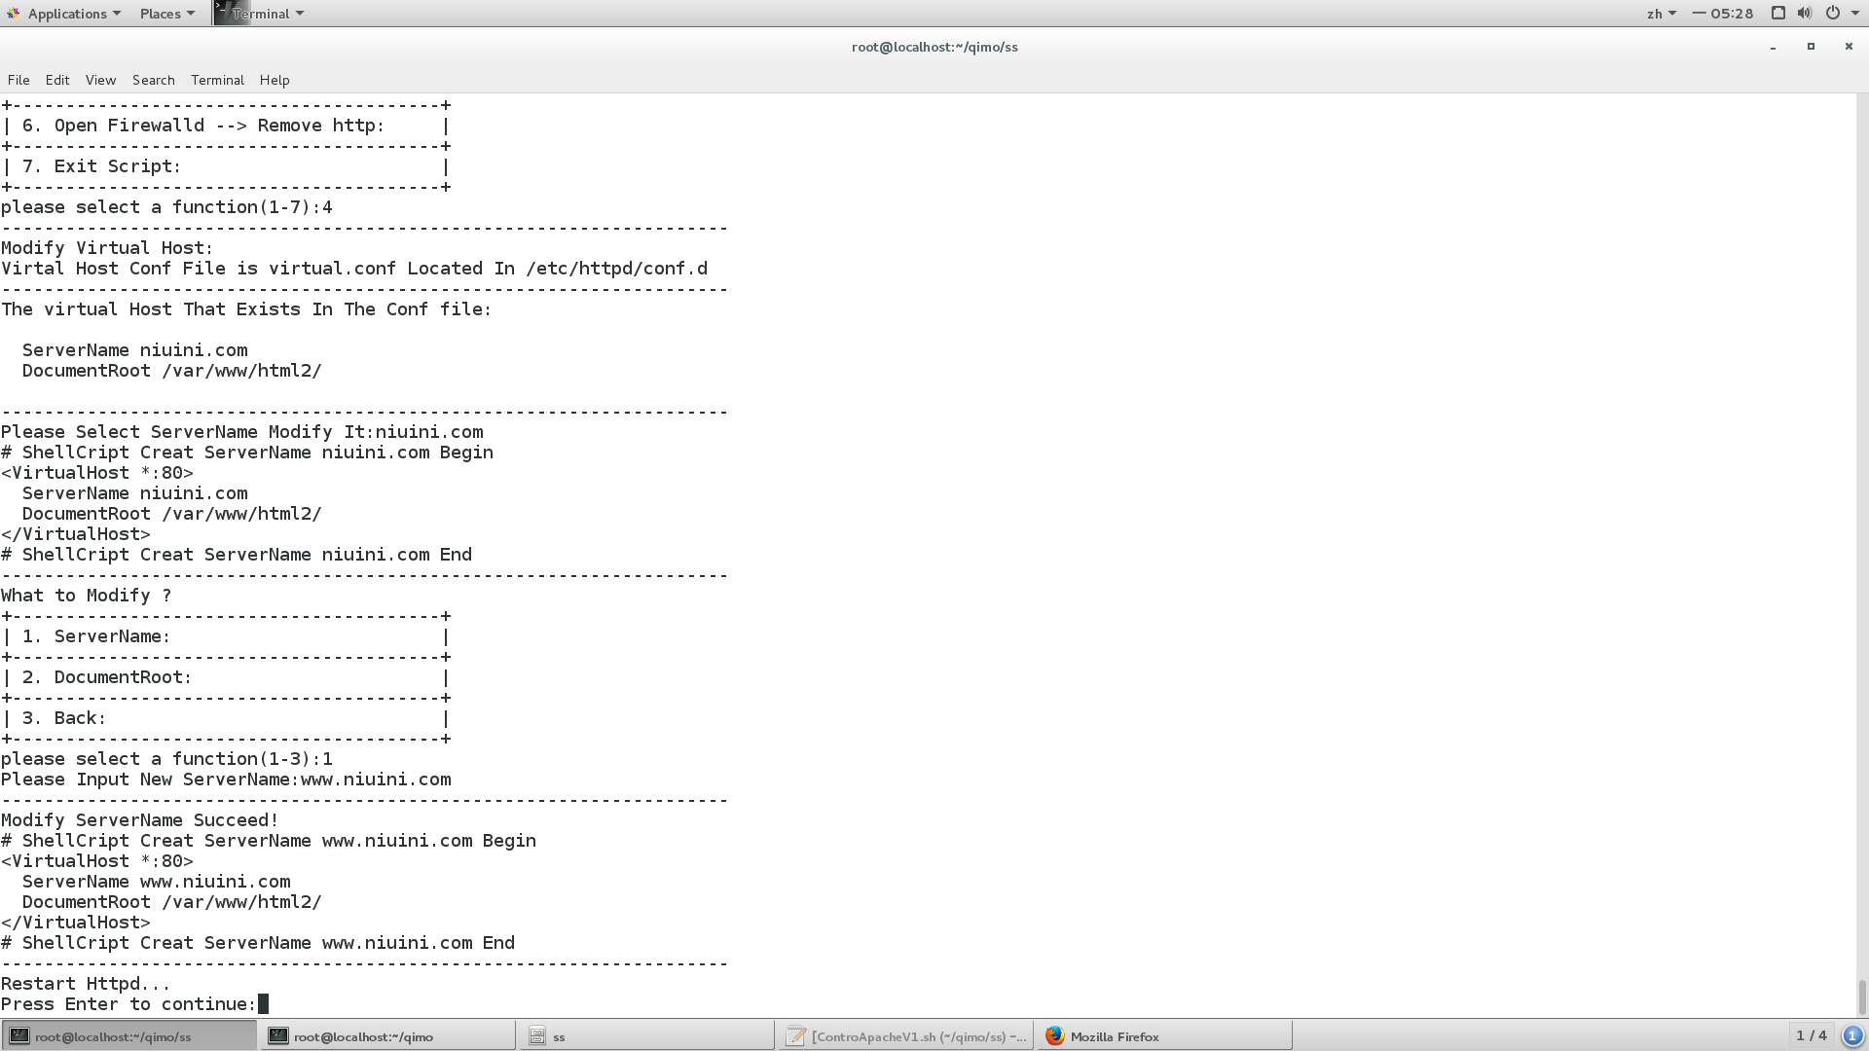

修改文档目录为 /var/www/html/

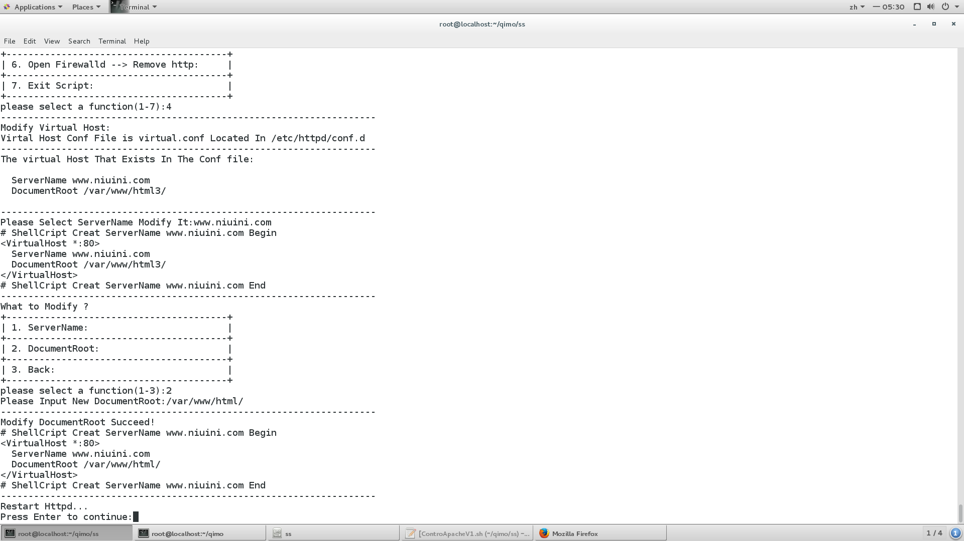

访问成功



### 打开防火墙并且添加http服务永久生效

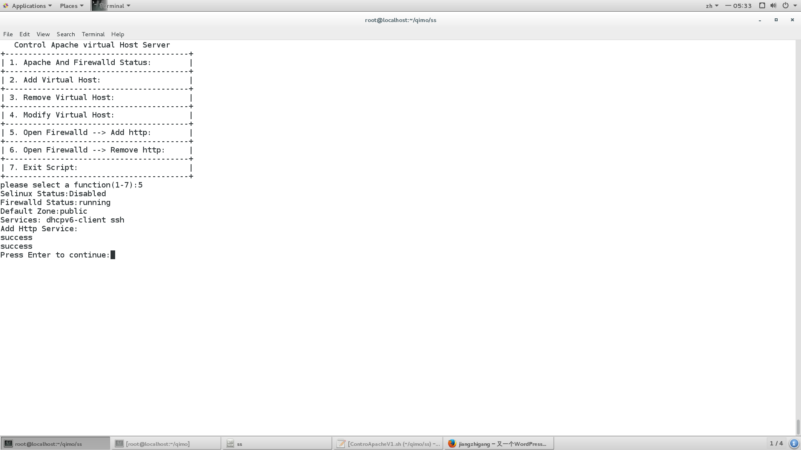

如果已经添加http服务则提示

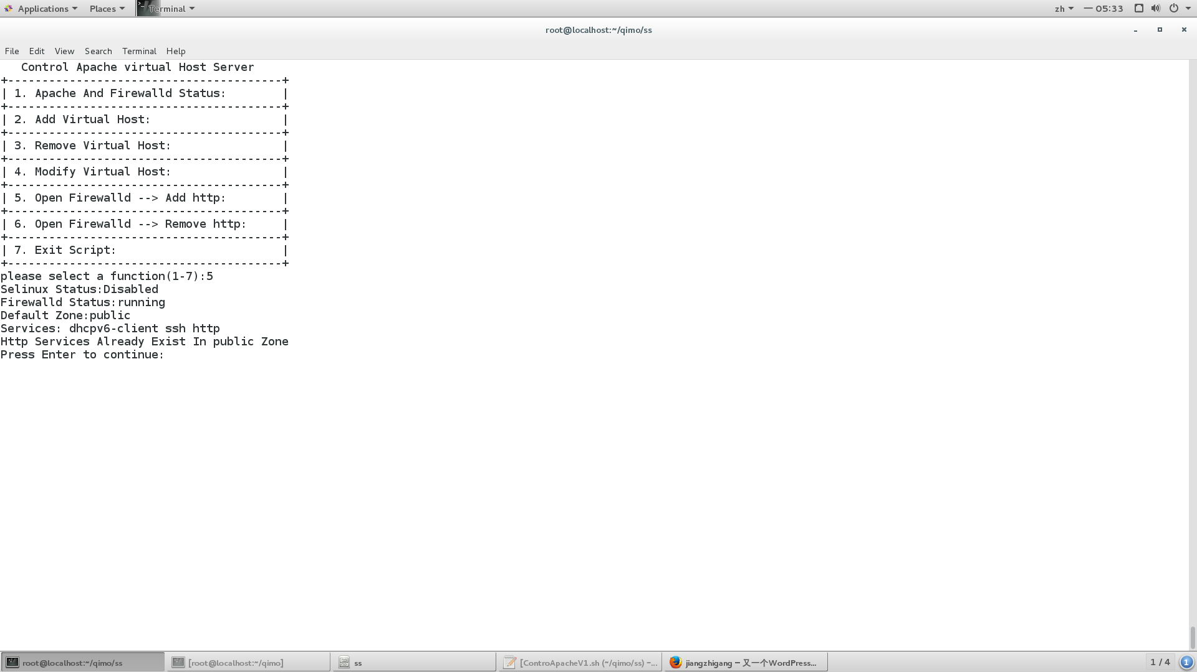

客户端 访问

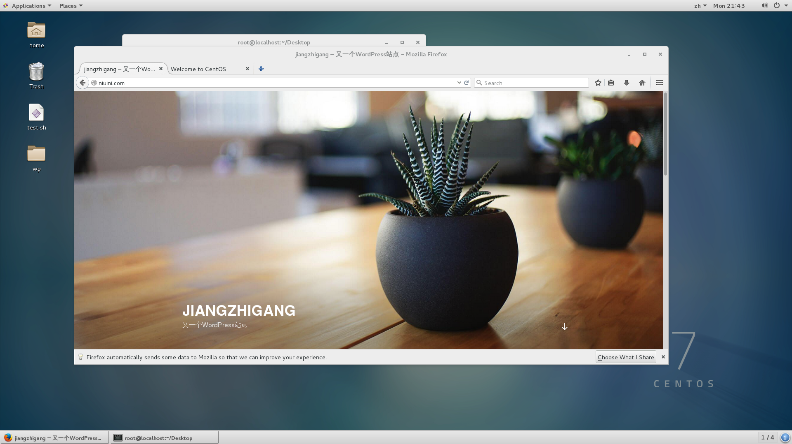

### 打开防火墙并且移除http服务永久生效

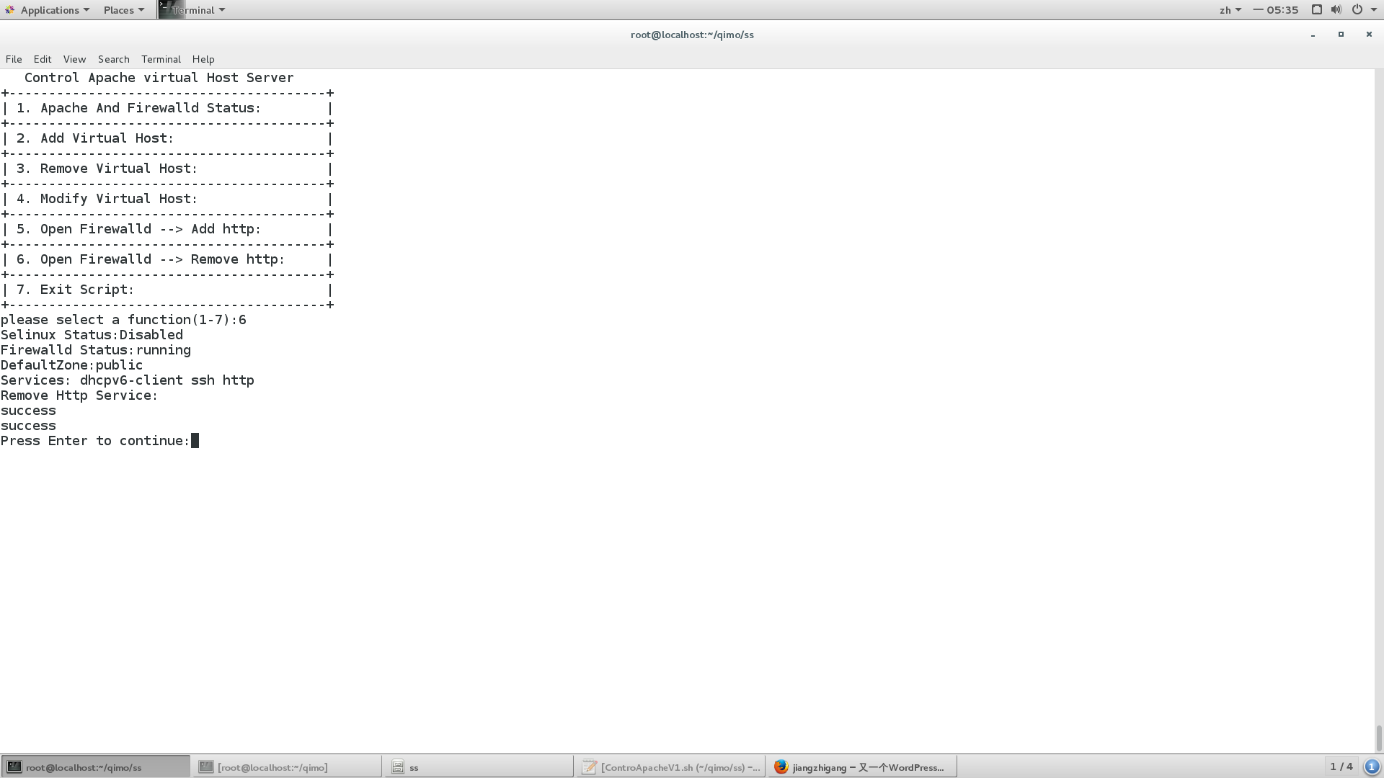

客户端访问

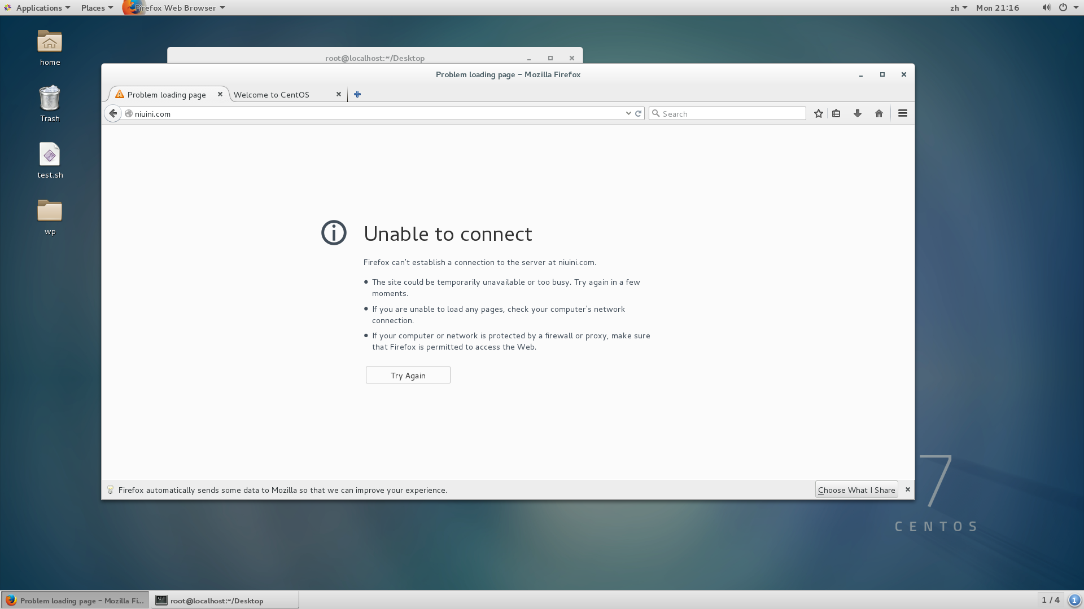

### 退出脚本

## 总结与展望

### 总结：

1.使用3台虚拟主机，搭建了一个小型网络，dhcp为其提供ip，dns为其提供域名解析，apache提供网页服务。

2.Dns和dhcp分开搭建，这样dhcp可以分配固定ip给dns服务器。

3.Dns客户端修改/ etc/resolve.conf 重启后失效 可以修改对应网卡配置文件

vim /etc/sysconfig/network-scripts/ifcfg-eno16777736

添加

NM_CONTROLLED=no

PEERDNS=yes

DNS1=192.168.140.102

这样重启后会自动添加 nameserver 192.168.140.102 到/ etc/resolve.conf

4. 配置apache基于域名的虚拟主机，应配置dns，使多个域名指向相同apache服务器，当apache服务器接受浏览器发送的不同头文件，其中包括用户输入的域名，来选择虚拟主机，指向不同目录，从而完成1台web服务器绑定多个域名。当客服端浏览器输入不在虚拟主机目录中的域名，而该域名又指向apache服务器，测试显示：会访问第一个虚拟主机的文档目录作为默认目录，而不会访问httpd.conf中的DocumentRoot。因为设置了NameVirtualHost *:80 。

### 展望：

虚拟主机的使用越来越频繁，一台主机可以绑定多个域名，符合当前一些用户的需求，该脚本功能比较简单，但是用户体验较好，会检测用户的输入，当用户输入为空，或者输入不存在，或者重复的内容时会提示。以后进一步完善脚本功能。

## 参考文献

1.周奇. Linux网络服务器配置、管理与实践教程[M]. 北京:清华大学出版社, 2011. 188-191

2. <https://blog.csdn.net/u011304615/article/details/71450847>； sed 匹配内容的前一行和后一行　添加内容，；2018年6月25日引自csdn博客

3. <https://www.cnblogs.com/wangkongming/p/3684905.html>； linux利用grep查看打印匹配的下几行或前后几行的命令 ；2018年6月25日引自cnblogs博客

4. https://blog.csdn.net/yf210yf/article/details/9207147；shell脚本----if（数字条件，字符串条件，字符串为空；2018年6月25日引自csdn博客

5. https://www.cnblogs.com/zqifa/p/linux-firewall-1.html；centos7下Firewall使用详解；2018年6月25日引自cnblogs博客